|  |  |
| --- | --- |
| cetlogo ***CHEMICAL ENGINEERING TRANSACTIONS***  ***VOL. , 2024*** | A publication of  aidiclogo_grande |
| The Italian Association  of Chemical Engineering  Online at www.cetjournal.it |
| Guest Editors:  Copyright © 2024, AIDIC Servizi S.r.l. **ISBN** 979-12-81206-10-6; **ISSN** 2283-9216 | |

Degradation of medium-density polystyrene by enzymatic extracts of *Aspergillus niger* using cassava peels as substrate

Laura B. Osorio, Nicolás Palacios, David L. Sotelo\*

Department of Environmental and Chemical Engineering, Fundación Universidad de América, Bogotá, Colombia.

david.sotelo@profesores.uamerica.edu.co

The accumulation of plastics and their resistance to being degraded naturally has caused different problems of pollution and accumulation at a global level, it is estimated that only 9% of the plastics produced annually are used or recycled correctly, which causes the other discarded percentage of these to generate negative impacts on the life and health of people and fauna on the planet. Expanded polystyrene (EPS) is one of the many resistant plastic materials and therefore very difficult to manage its disposal and be degraded due to its high molecular weight. About 4.8 and 12.7 million tons of EPS are discarded annually worldwide, and it is vitally important to find sustainable alternatives for their treatment. This work evaluates the degradation of medium-density EPS sheets using crude enzymatic extracts obtained from the filamentous fungus *Aspergillus niger*, using *Manihot* *esculenta* (cassava) peels, an unused agro-industrial and culinary waste, as a substrate for their cultivation. The polymer samples were pretreated and then put in contact with the enzyme extract for a period of 30 days. The results show an average degradation of 2.12%, indicating a high degradation in the studied sheets with structural losses evident under the microscope, suggesting that a longer exposure time could increase the percentage of degradation.

1. **Introduction**

Styrene is the monomer of polystyrene, it is obtained from ethylbenzene, a hydrocarbon resulting from the reaction of benzene with ethylene that is used almost exclusively for the production of styrene. The characteristic properties of this polymer are durability and that it is lightweight, with a high thermal resistance, which makes it very frequently used in the construction sector to food packaging (Ba Thanh Ho et al., 2018). These same properties and its extensive use make this material a major concern due to the time it takes for its complete degradation as it can last for up to 500 years (Chandra et al., 2016). It is estimated that by 2025 the consumption of EPS will increase by 3.6 % since between 2018 and 2019 approximately 15.5 million tons were produced, by 2024 these figures could increase to 15.68 million tons in regions such as Asia (Elgharbawy, 2023). The final destination of EPS is in landfills or incineration, the latter causing the release of toxic gases, such as hydrogen bromide (Argentine Association of Expanded Polystyrene, 2005). There are several thermal and chemical techniques for recycling EPS waste, but the latter involve the use of hazardous solvents (Poletto et al., 2011) and can therefore be quite polluting. As the disposal and degradation of EPS are difficult tasks, there are alternatives that involve the action of microorganisms to attack this problem, such as taking advantage of their capabilities to take the polymer as a carbon source or their abilities to produce enzymes capable of degrading it. The influence of different types of sugars on the variation of production of enzymes such as ɑ-amylases by fungi that are capable of degrading carbohydrate-bound polymers is described, where *Aspergillus niger* showed a percentage of polymer degradation measured in weight loss with 20.4 % when the bounded carbohydrate was glucose (Galgali et al., 2004). Taking into account the preferences of the fungus for growing in media with high glucose contents, the peel of *Manihot esculenta* as a residue is considered a good candidate for substrate since it is rich in polysaccharides such as starch of which it contains approximately 35 % on a dry basis (Román et al., 2015), and which can be used to grow fungi such as *Aspergillus niger*, "It is estimated that 11 million tons of peels are generated annually in the world, which covers approximately 3 % to 5 % of the total weight of cassava roots." (Del Rio et al., 2021). The advantage of these strategies for the treatment of EPS is influenced by the use of agro-industrial residues as substrates for the growth of the fungus and the production of the extract to degrade. The objective of this research is to evaluate the degradation of EPS exposed to enzymatic extracts of *Aspergillus niger* using *Manihot esculenta* peels as a substrate, as it offers a possible solution to address the problem of degradation and accumulation of this type of polymers. These enzymes have the ability to break chemical bonds in the polymer chain, breaking down into smaller fragments that are more easily biodegradable. This would accelerate the degradation process and reduce its accumulation, making this a technological alternative with a focus on environmental sustainability.

1. **Methods and materials**

**2.1 Substrate**

Cassava peels residues were obtained from the market square of Paloquemao, in the city of Bogota, Colombia.

**2.2 Reagents**

Protein albumin was commercially acquired and used as a comparison standard for the determination of the protein concentration of the extract. The Biuret reagent, which was prepared by modifying as reported by Gregor et al. (1976). The reagents needed to develop the polyacrylamide electrophoresis analysis were purchased from Sigma-Aldrich.

**2.3 Microorganism**

The strain of *Aspergillus niger* registered as CMPUJ:H002 was acquired from the Pontificia Universidad Javeriana’s ceparium and preserved in a solution of 30% glycerol and Sabouraud broth at 2 ºC.

**2.4 Activation of the fungus and culture of the microorganism**

The *A. niger* strain was grown in a medium with 4.2 g/L glucose and 8.12 g/L Sabouraud Agar at a temperature of 30 °C for 8 days. The propagation of the microorganism was carried out in the medium with the defined substrate, adding approximately 13.10 g of cassava peels in sheets previously sterilized in an autoclave and 3.68 g/L of Agar - Agar in 125 mL of deionized water for an incubation period of 8 days at 30 °C.

**2.5 Obtaining the enzyme extract**

The extraction process starts with the fungus at maximum growth, which is identified after 8 days when the fungus presents its characteristic black coloration and has almost completely covered the peel sample placed in the petri dish. This is followed by the addition of 20 mL of deionized water to each sample box and stirred for at least 72 hours at 120 rpm at a temperature of 30 °C. Once the stirring time is over, each fungus sample is extracted by means of vacuum filtration (Büchner funnel assembly) using filter paper as a filter medium and the liquid obtained is packaged in 15 mL falcon tubes to be centrifuged for 20 min at a speed of 3600 rpm in order to sediment mycelia or solid particles of the sample that may have remained.

**2.6 Characterization of the enzyme extract**

**2.6.1 Quantification by Biuret method**

A calibration curve with concentrations between 500 and 8000 ppm was developed using bovine serum albumin as a standard, starting from a stock solution of 10,000 ppm with which a correlation coefficient of 0.993 was obtained (Figure 2). Based on this data, the protein quantification is carried out with the Biuret method, which consists of the absorbance analysis of each extract sample by taking different volumes and dissolving them in water by also adding 1 mL of the reagent, this data will be taken as "Y" in the equation of the straight line given by the calibration curve, which will finally obtain the value of the protein concentration expressed in ppm of each extract sample taken.

**2.6.2 Protein size determination by electrophoresis**

The test was carried out using the SDS PAGE - Native electrophoresis technique to determine the size of the proteins in the extract by means of an electric current charge to move the molecules through a 10% polyacrylamide gel, allowing the division of the molecules by size to be made visible in the form of a sieve compared with the already standardized molecular weight marker that gives a guide to the approximate molecule sizes of the result to be obtained.

**2.7 Degradation of polystyrene**

**2.7.1 UV light pretreatment**

14 sheets of approximately 3.5 cm \* 2 cm of EPS were exposed in a closed booth with UV light for a period of 15 days as a pretreatment to reduce the hydrophobicity of the plastic and to generate oxygen free radicals within the polymer structure, these free radicals can participate in polymer pathways to form shorter-chain compounds such as ketones and olefins prone to being attacked by the enzymes present in the enzyme extract for their subsequent degradation, weakening the structure of the polymer sheets, accelerating this process in the tests.

**2.7.2 Degradation testing (Exposure to the extract)**

To perform this test, each sheet of polystyrene was placed in a petri dish adding 10 mL of obtained extract with a pH of 4.83 and a concentration of 3,000 ppm, followed by this each petri dish was stored in a drawer at room temperature and without agitation for 30 days. The degradation analysis was calculated by mass difference where a blank sample was taken (EPS sheet previously exposed to UV treatment and stored in a petri dish with 10 mL of water under the same temperature and time conditions), in order to have a standard point with which to compare the changes in mass and structure of the sheets exposed to the extract and thus determine their percentage of degradation by going through a drying process in a sterilized booth during 24 hours and a microscopic and mass analysis being weighed on a scale, comparing with the weights taken before exposure to the extract.

1. **Results and discussion**

**3.1 Growth of the fungus in the cassava peel medium**

As can be seen, once the 8 days of incubation have been completed, maintaining a temperature of 30°C, the colonization of the fungus is occupying the entire area that corresponds to the peel of *Manihot* *esculenta* (Figure 1a). Taking this into account, at the time of performing different tests of the culture medium with the cassava peels with the same conditions of time and temperature (8 days at 30°C), the result is that the sample containing the grinded peel on the agar-agar, as seen in Figure 1b, presents a low expansion and low growth of the fungus compared to the sample that was cultured with the no altered cassava peels (Figure 1c), demonstrating that the most suitable way to obtain the nutrients from the substrate for its growth and maximum expansion in the petri dish is with the complete peel sheets inside the agar-agar.

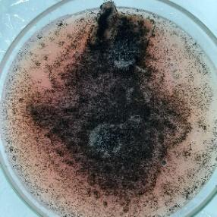 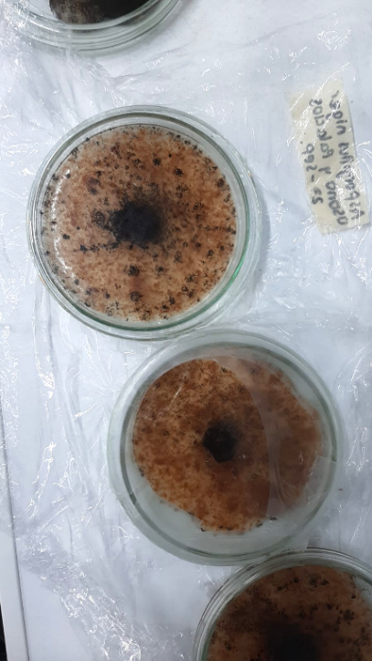 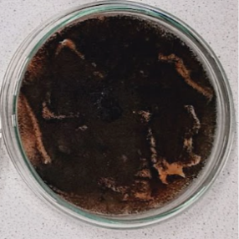

*Figure 1. Colonization of the fungus over the cassava peel. (a) Colonization on the cassava peel area; (b) Colonization on grinded peels; (c) Total fungal growth on cassava peel sheets distributed over the petri dish.*

It was determined for the extraction that the samples would be left in agitation for 72 hours at 120 rpm, this since as reported by El-Enshay et al. (2006) the speed of agitation is a determining factor in protein synthesis, where the authors use a speed of 200 - 800 rpm for 60 min but it is indicated that when using longer agitation time there is a higher concentration of proteins inside of the final extract. The extract obtained from each petri dish had a yellow hue, due to the presence of yellow pigments produced by the fungus, which indicates a good production of this extract, in addition to a good amount of it necessary for the degradation of the EPS sheets.

**3.2 Protein quantification**

**3.2.1 Biuret method**

To calculate the protein by this method, 6 samples of extracts obtained on different dates were analyzed (Table 1), giving as a result in the first 2 less protein, since the growth of these was in the grinded peels, while the other tests that were made in complete laminas had a higher result. This calculation was made with the equation of the straight line obtained in the albumin calibration curve (Figure 2), and the correlation coefficient of 0.993.

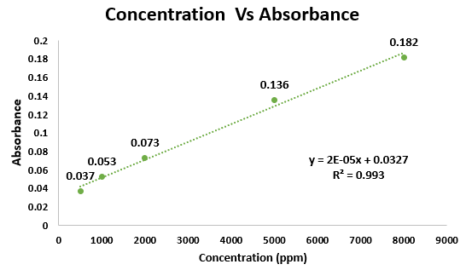

*Figure 2. Albumin calibration curve obtained in experimentation*

*Table 1. Absorbance and protein quantification of extracts obtained during experimentation by Biuret method.*

|  |  |  |  |
| --- | --- | --- | --- |
| Obtention date (DD-MM) | Absorbance | Concentration (mg/L) |  |
| 28/09 | 0.070 | 1890 |  |
| 10/10 | 0.085 | 2790 |  |
| 21/10 | 0.166 | 6665 |  |
| 30/10 | 0.142 | 5465 |  |
| 15/11 | 0.142 | 5465 |  |
| 17/11 | 0.120 | 4365 |  |

**3.2.2 Electrophoresis analysis**

In the gel obtained from the Electrophoresis (Figure 3) it can be seen on the left side (A) the molecular-weight size marker that standardizes the approximate size of the proteins that were processed and on the right side (B) the result of the test for the sample of enzyme extract, of which only one test was done due to time. The lines where they coincide can give an idea of the sizes of the proteins present in the extract where enzymes were obtained with values close to those standardized by the marker, which allows them to be assigned to the enzyme families that are within these ranges. It should be noted that amyloglucosidases are between 82-114 kDa, therefore the first could correspond to this group indicating values close to 116.0 kDa, this coincides with the data obtained by Sánchez (2005) in studies of native strains where they even recommend the purification of proteins to measure the most specific activity. In the second mark, the result could be located at a value close to 66.2 kDa, so the enzymes that are present in it could be part of the enzymatic family of ɑ-amylases, however, this variation has great dependence on the microbial strain, the substrate used and even the fermentation process as reported by Mohd and Darah (2021) since the recording of their molecular weights ranges from 58 kDa to 66 kDa for the same enzyme family. And finally, the third band that is positioned in the approximate range between 45.0 kDa and 35.0 kDa would be part of the pectinase enzyme group, since the weight of this group is around 30 kDa to 40 kDa as reported by Morales et al. (2022) in saline rainfall of a crude extract with cellulolytic activity produced by *Aspergillus* *niger*.

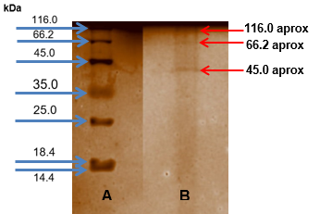

*Figure 3. Electrophoresis analysis. (a) Molecular-weight size marker; (b) Extract sample*

**3.3 Polymer degradation**

When performing the mass difference tests to demonstrate the degradation process (Figure 4), the extract is maintained with a pH result of 4.83, the ideal range for degradation as demonstrated by Xueyan Hu (2016) where there is evidence that it should have a pH in a range of 4 to 1. After 30 days of exposure to the extract, it is possible to identify through microscopic and mass difference review that high levels of degradation are reached for such a short period of time (Table 2), reaching an average of 2.12 % degradation of EPS (Table 3) under room temperature conditions which on a large scale and over a longer period of time could represent a successful degradation, considerably reducing the time in which it occurs polymer degrades normally.

*Table 2. Difference in mass and percentage of degradation of EPS sheets.*

|  |  |  |  |
| --- | --- | --- | --- |
| Sample | Initial weight (g) | Final weight (g) | Degradation (%) |
| Blank | 0.1483 | 0.1483 | 0.00 |
| 1 | 0.1544 | 0.1496 | 3.11 |
| 2 | 0.1573 | 0.1533 | 2.54 |
| 3 | 0.1598 | 0.1544 | 3.38 |
| 4 | 0.1568 | 0.1523 | 2.87 |
| 5 | 0.1584 | 0.1569 | 0.95 |
| 6 | 0.1557 | 0.1526 | 1.99 |

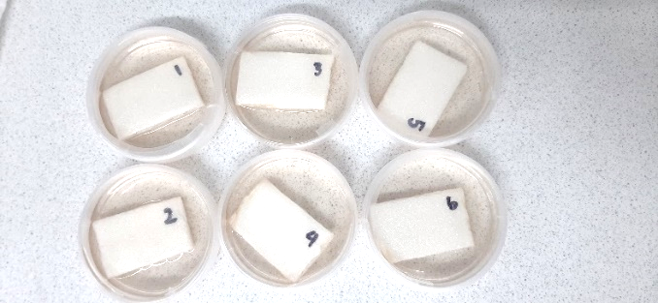

*Figure 4. EPS specimens in contact with the enzymatic extract of Aspergillus niger.*

*Table 3. Average of the percentage of degradation, standard deviation and coefficient of variation.*

|  |  |
| --- | --- |
| Average (%) | 2.12 |
| Standard deviation | 1.238 |
| Coefficient of variation | 58.387 |

As a result of the microscopy analysis, the structural loss of the EPS sheets is identified by comparing Figure 5a of the blank sample where the structure of each "bubble" is complete, without any damage and of an average size, then it changes as observed in Figure 5c which corresponds to the sheet after 30 days of degradation and has a different structure where the bubbles present small ruptures within them and divisions in their membranes, even causing more to become visible than there were before going through the degradation process, as evidenced in Figure 5b. An analysis of this behavior, indicates that the enzymatic extract is able to weak these membranes more quickly than polystyrene would under neutral conditions (without any type of treatment to degrade), causing the sheet to lose stability, making it a material prone to the action of enzymes.



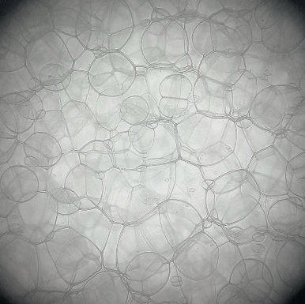 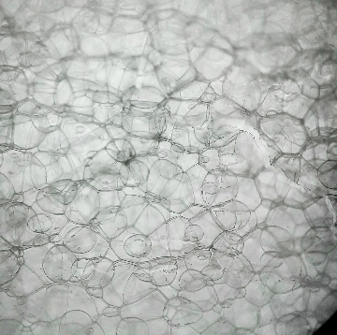 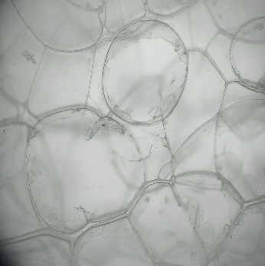

*Figure 5. Microscopic identification of degradation. (a) Blank Sample; (b) Polystyrene sheets structure after 30 days; (c) Increasing fragmented structure of EPS membranes.*

1. **Conclusions**

The obtaining of enzymatic extracts using agro-industrial residues that are not currently usable, such as the peels of *Manihot esculenta*, shows that this is a suitable substrate for the fungus *Aspergillus niger*, obtaining an ideal growth of the fungus and the quantity of enzymes such as cellulase, amyloglucosidases and pectinases necessary in its extract since through it the degradation of the EPS was possible. It was evaluated quantitatively and qualitatively by identifying the mass losses and the partial structural loss of the material in a period of 30 days after exposure to the extract. The results of this analysis demonstrate that during this period of time, EPS in an enzymatic extract medium with a concentration of 3000 ppm achieves an approximate mass loss of 2.2%, which suggests that prolonging exposure could increase this percentage of degradation, much faster than the 500 years it takes for the polymer to degrade naturally. On the other hand, under the microscope the denaturation of EPS sheets that were exposed for 30 days, is seen in a more porous aspect compared to the blank sample sheet, which remained in its initial state. Finally, for those who continue with this project, take into account the tests carried out in this work and its results such as the use of the peel in sheets for the growth of the fungus, a second deeper filtration of the extract to minimize chances of mycelia fungus growing in the samples during the degradation time and finally, to run as many as possible electrophoresis tests to get more data to compare to, which allows to identify in a more accurate way the sizes of the particles expressed in the extracts.

**References**

Adebare, B. S., Johnson, A. A., Olanrewaju, T. M., Titilope, A. O., Femi, B. P., Bankole, S. A., Joseph, I. O., & Joshua, A. A. (2021). Production and optimization of alpha amylase from Aspergillus niger using TME 419 cassava peel as substrate. African Journal of Biological Sciences, 3(4), 50. <https://doi.org/10.33472/afjbs.3.4.2021.50-59>

Bellaouchi, R., Abouloifa, H., Rokni, Y., Hasnaoui, A., Ghabbour, N., Hakkou, A., Bechchari, A., & Asehraou, A. (2021). Characterization and optimization of extracellular enzymes production by Aspergillus niger strains isolated from date by-products. Journal, Genetic Engineering & Biotechnology, 19(1), 50. <https://doi.org/10.1186/s43141-021-00145-y>

Del Rio, C. T. (2021). Valorization of industrial waste in cassava starch production. Prospectiva, 19(2). <https://doi.org/10.15665/rp.v19i2.2556> (in Spanish)

Elgharbawy, A. (2023). Expandable Polystyrene Production and Market Survey- A Review. Egyptian Journal of Chemis, 66(5), 87–91.

Galgali, P. (2004). Fungal degradation of carbohydrate-linked polystyrenes. Carbohydrate Polymers, 55(4), 393–399. <https://doi.org/10.1016/j.carbpol.2003.10.011>

Ho, B. T., Roberts, T. K., & Lucas, S. (2018). An overview on biodegradation of polystyrene and modified polystyrene: the microbial approach. Critical Reviews in Biotechnology, 38(2), 308–320. <https://doi.org/10.1080/07388551.2017.1355293>

Hu, X., Gao, Z., Wang, Z., Su, T., Yang, L., & Li, P. (2016). Enzymatic degradation of poly(butylene succinate) by cutinase cloned from Fusarium solani. Polymer Degradation and Stability, 134, 211–219. <https://doi.org/10.1016/j.polymdegradstab.2016.10.012>

Jalil, M. T. M., & Ibrahim, D. (2021). Partial purification and characterisation of pectinase produced by Aspergillus niger LFP-1 grown on pomelo peels as a substrate. Tropical Life Sciences Research, 32(1), 1–22. <https://doi.org/10.21315/tlsr2021.32.1.1>

Lingqia, S., Ruoyu, H., Demin, K., & Jing, W. (2020). Enhanced activity towards polyacrylates and poly(vinyl acetate) by site-directed mutagenesis of Humicola insolens cutinase. International Journal of Biological Macromolecules, 162, 1752–1759. <https://doi.org/10.1016/j.ijbiomac.2020.07.261>

Martínez López, C., & Laines Canepa, J. R. (2014). Expanded polystyrene and its environmental problems. Kuxulkab, 19(36). <https://doi.org/10.19136/kuxulkab.a19n36.339> (in Spanish)

Mohanan, N., Montazer, Z., Sharma, P. K., & Levin, D. B. (2020). Microbial and enzymatic degradation of synthetic plastics. Frontiers in Microbiology, 11, 580709. <https://doi.org/10.3389/fmicb.2020.580709>

Morales Borrell, D., Baryolo González, L., Mora González, N., Ramos Sánchez, L. B., & Pérez Sánchez, A. (2022). Saline precipitation of a crude extract with cellulolytic activity produced by Aspergillus niger. UC33. Colombian Journal of Agroindustrial research, 9(2), 69–85. <https://doi.org/10.23850/24220582.4872> (in Spanish)

Navinchandra G. Shimpi, Mahesh Borane, Satyendra Mishra. (2013). Biodegradation of PS: PLA and PS: PLA: OMMT Nanocomposites Using Aspergillus Niger. Polymer Composi, 35(2), 263–272.

Ranjan, V. P., & Goel, S. (2019). Degradation of low-density polyethylene film exposed to UV radiation in four environments. Journal of Hazardous, Toxic and Radioactive Waste, 23(4), 04019015. <https://doi.org/10.1061/(asce)hz.2153-5515.0000453>

Restrepo-Flórez, J.-M., Bassi, A., & Thompson, M. R. (2014). Microbial degradation and deterioration of polyethylene – A review. International Biodeterioration & Biodegradation, 88, 83–90. <https://doi.org/10.1016/j.ibiod.2013.12.014>

Savoldelli, J., Tomback, D., & Savoldelli, H. (2017). Breaking down polystyrene through the application of a two-step thermal degradation and bacterial method to produce usable byproducts. Waste Management (New York, N.Y.), 60, 123–126. <https://doi.org/10.1016/j.wasman.2016.04.017>

Shi, K., Jing, J., Song, L., Su, T., & Wang, Z. (2020). Enzymatic hydrolysis of polyester: Degradation of poly(ε-caprolactone) by Candida antarctica lipase and Fusarium solani cutinase. International Journal of Biological Macromolecules, 144, 183–189. <https://doi.org/10.1016/j.ijbiomac.2019.12.105>

Sulyman, A. O., Igunnu, A., & Malomo, S. O. (2020). Isolation, purification and characterization of cellulase produced by Aspergillus niger cultured on Arachis hypogaea shells. Heliyon, 6(12), e05668. <https://doi.org/10.1016/j.heliyon.2020.e05668>

Taddia, A., Brandaleze, G. N., Boggione, M. J., Bortolato, S. A., & Tubio, G. (2020). An integrated approach to the sustainable production of xylanolytic enzymes from Aspergillus niger using agro-industrial by-products. Preparative Biochemistry & Biotechnology, 50(10), 979–991. <https://doi.org/10.1080/10826068.2020.1777425>

Taghavi, N., Zhuang, W.-Q., & Baroutian, S. (2021). Enhanced biodegradation of non-biodegradable plastics by UV radiation: Part 1. Journal of Environmental Chemical Engineering, 9(6), 106464. <https://doi.org/10.1016/j.jece.2021.106464>

Tania Surya Utami, Ines Hariyani, Gandhi Alamsyah, Heri Hermansyah. (2017). Production of Extracellular Lipase from Aspergillus Niger by Solid-State Fermentation. Energy Proced, 136, 41–46.

Yousif, E., & Haddad, R. (2013). Photodegradation and photostabilization of polymers, especially polystyrene: review. SpringerPlus, 2(1), 398. <https://doi.org/10.1186/2193-1801-2-398>

Zhang, Y., Pedersen, J. N., Eser, B. E., & Guo, Z. (2022). Biodegradation of polyethylene and polystyrene: From microbial deterioration to enzyme discovery. Biotechnology Advances, 60(107991), 107991. <https://doi.org/10.1016/j.biotechadv.2022.107991>